**Practical no 2B**

**Aim: use Cain and Abel for cracking windows account password using dictionary attack and to decode wireless network passwords**

How to download and install Cain and able.

(1) Download and Install Cain and able software in your system. For this you need to turn off your firewall.

Extract the CainandAble.rar file in VMWare -> Turn off the windows security firewall.

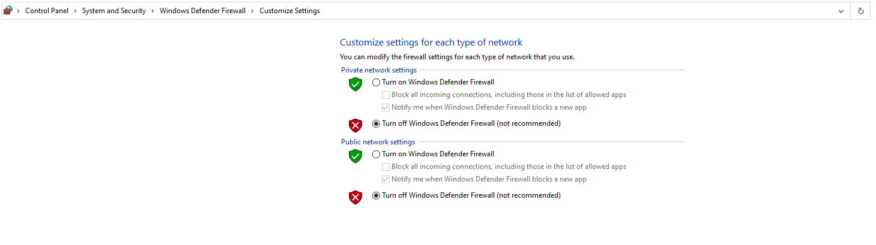

After installation, open the software you will see a page as displayed below.

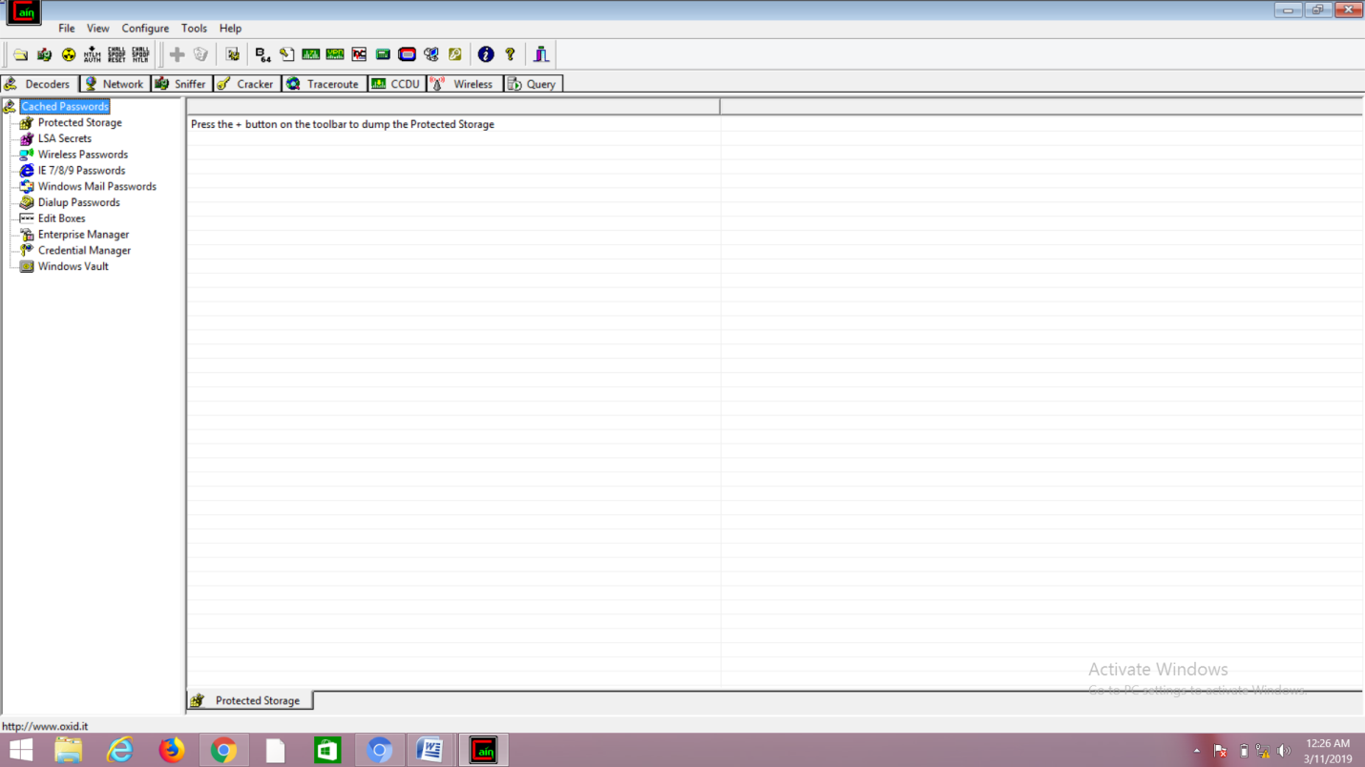

(2) Click on "Hash Calculator"

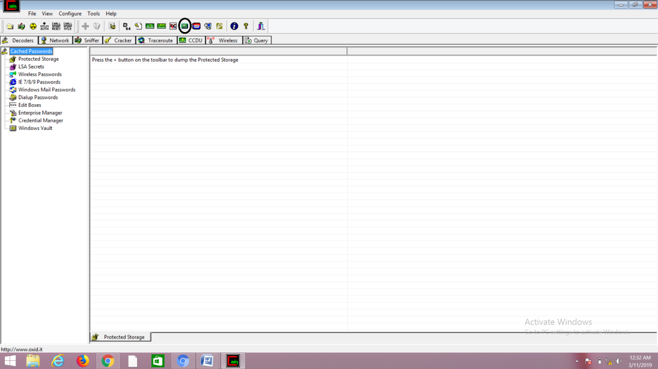

(2) Enter the text which you want to convert to "Hash" and click on "calculate" button.

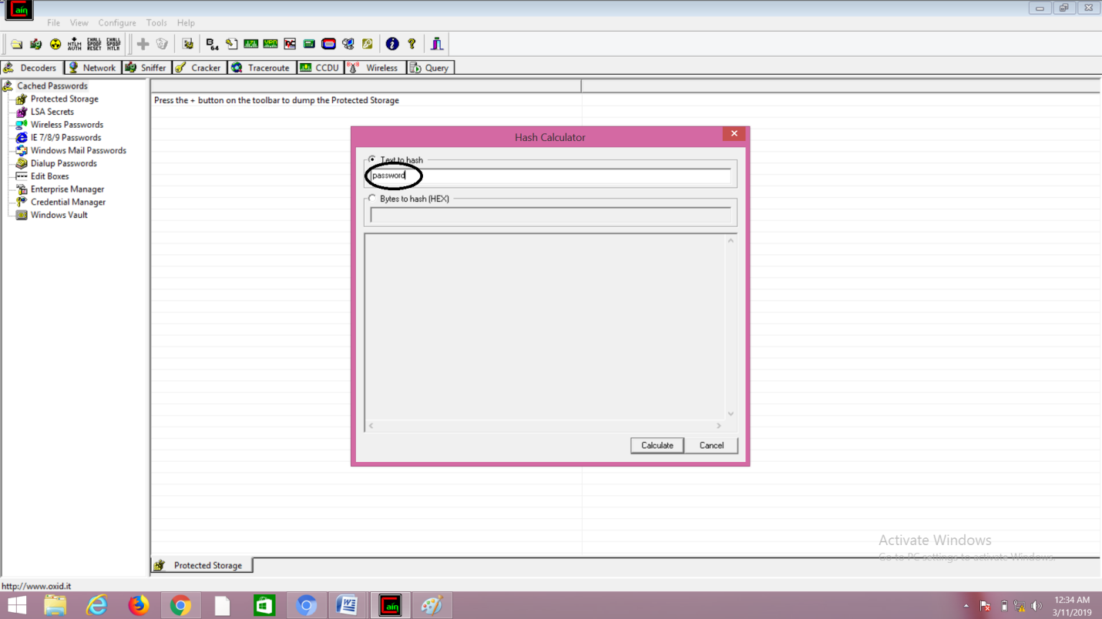

(3)copy the value into the field you have converted.(eg:MD5),and then click on "cancel" button.

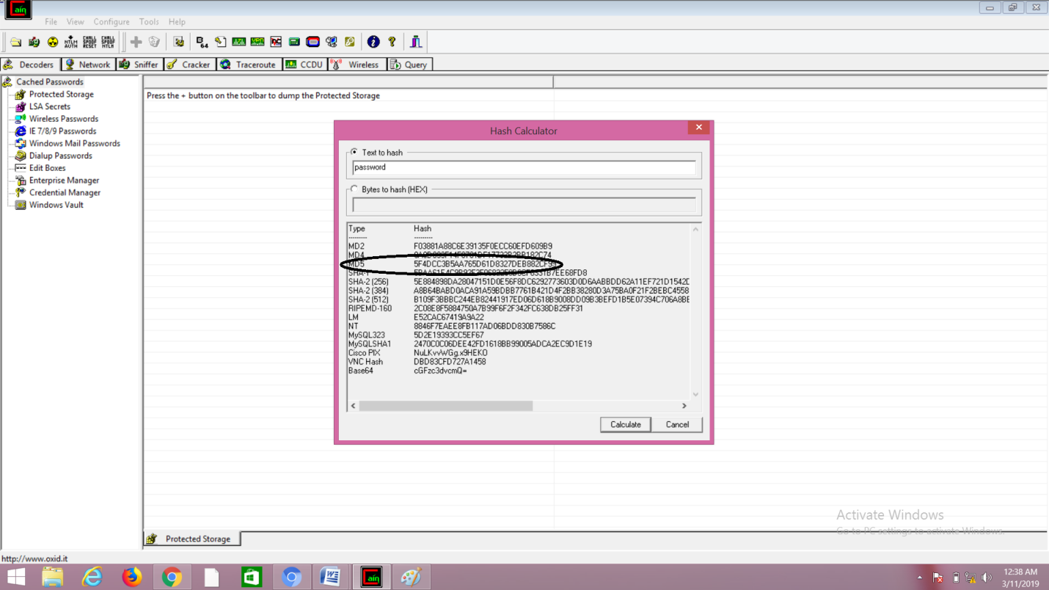

(4) After that go to cracker>MD5 hashes and click on "+" icon on the top of the page. After that, a dialog window will appear and it will ask you to enter your MD5 hashes. Now, paste the MD5 hash which you have copied earlier and then click on the "ok" button.

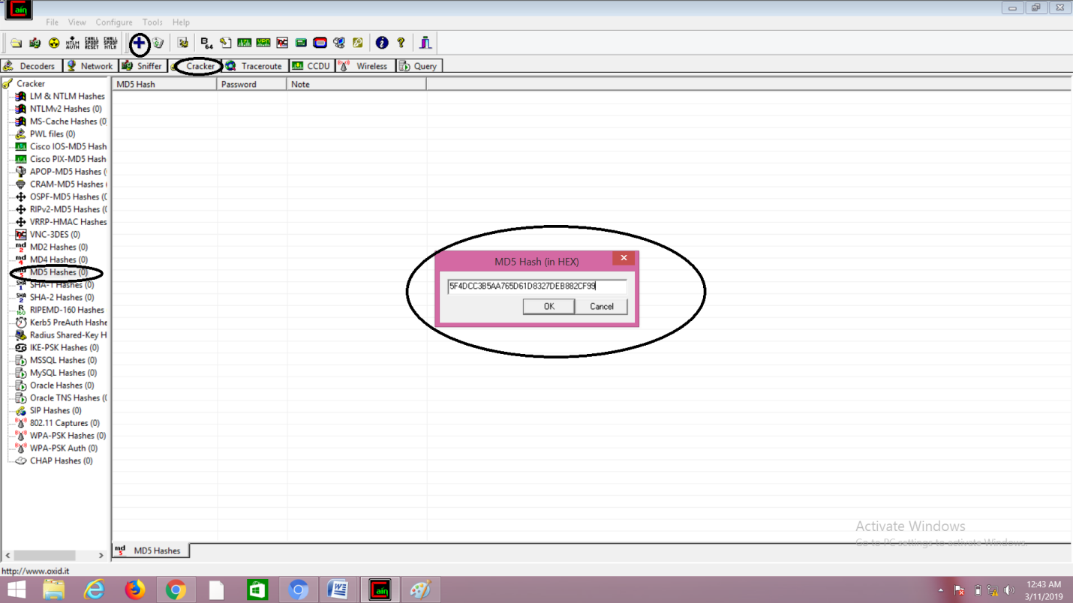

(5) After performing step (4) right click on MD5 hash and select "Dictionary Attack"

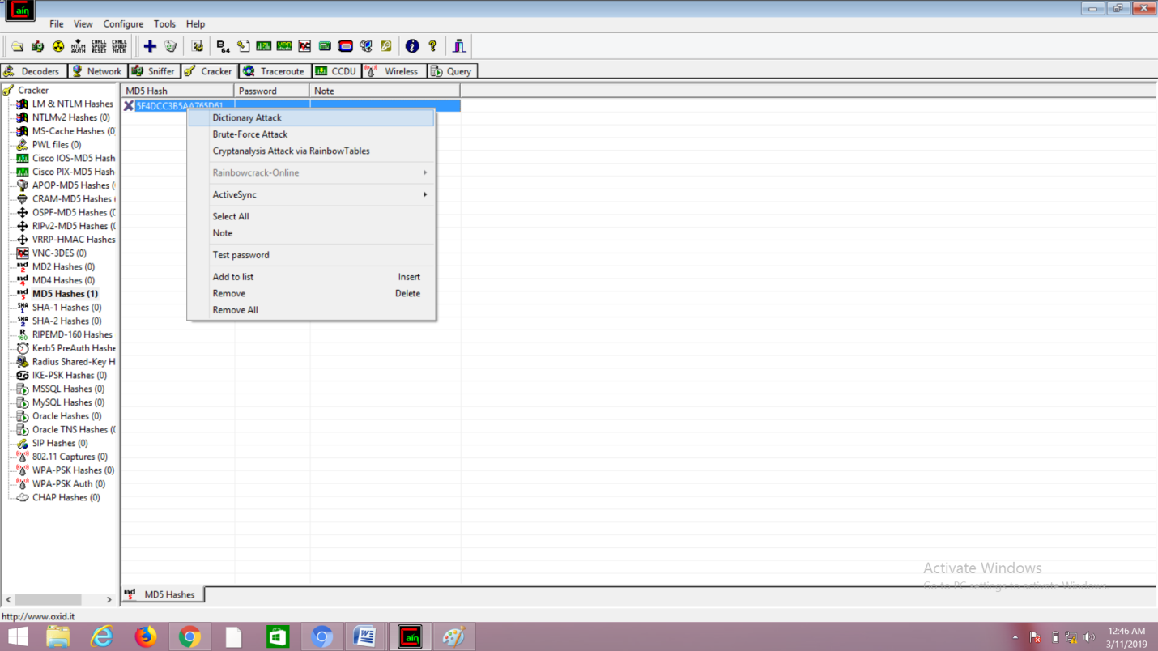

(6) right click on the file and select(Add to list)and then select the wordlist file from the following path:

C:\Program Files (x86)\Cain\Wordlists

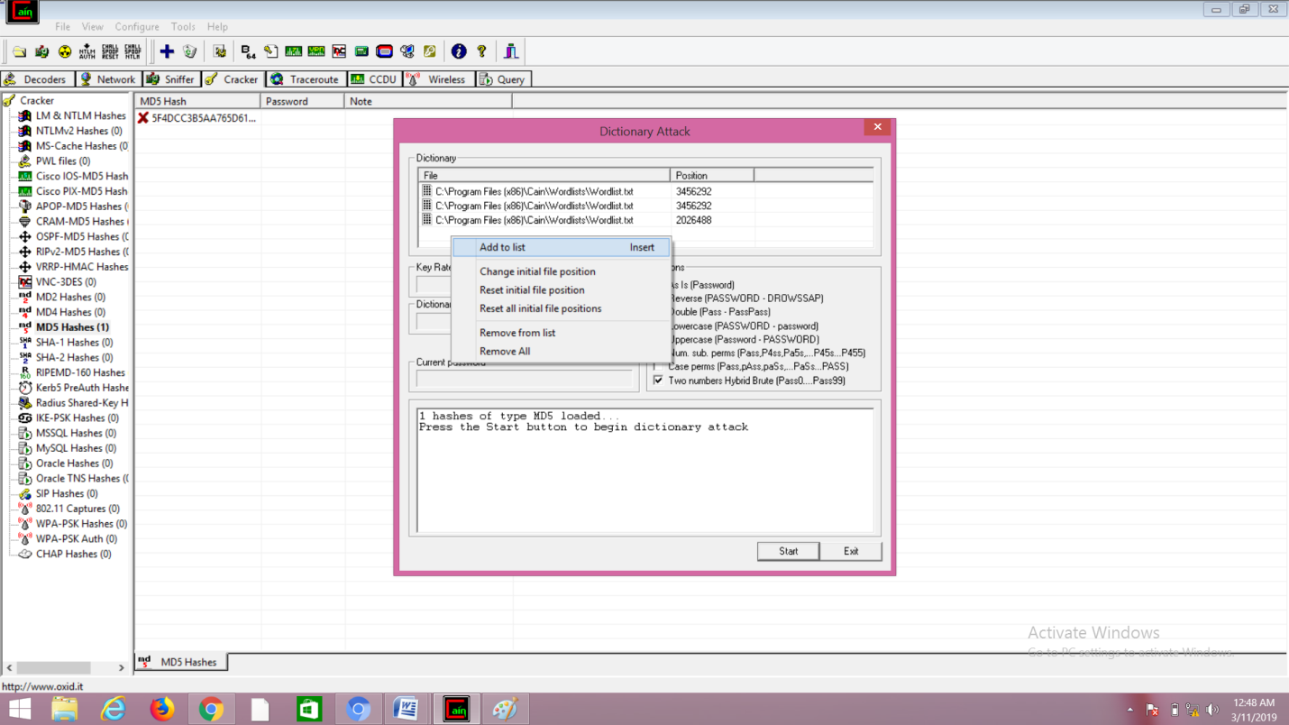

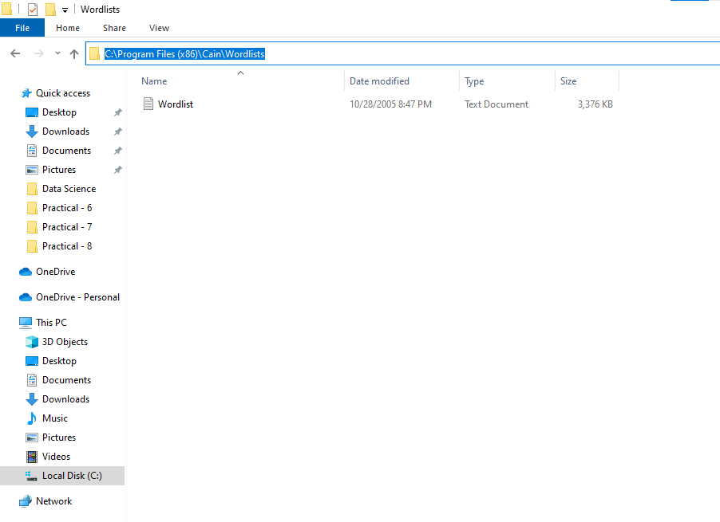

(7) Select all the options and click on "Start" Button.

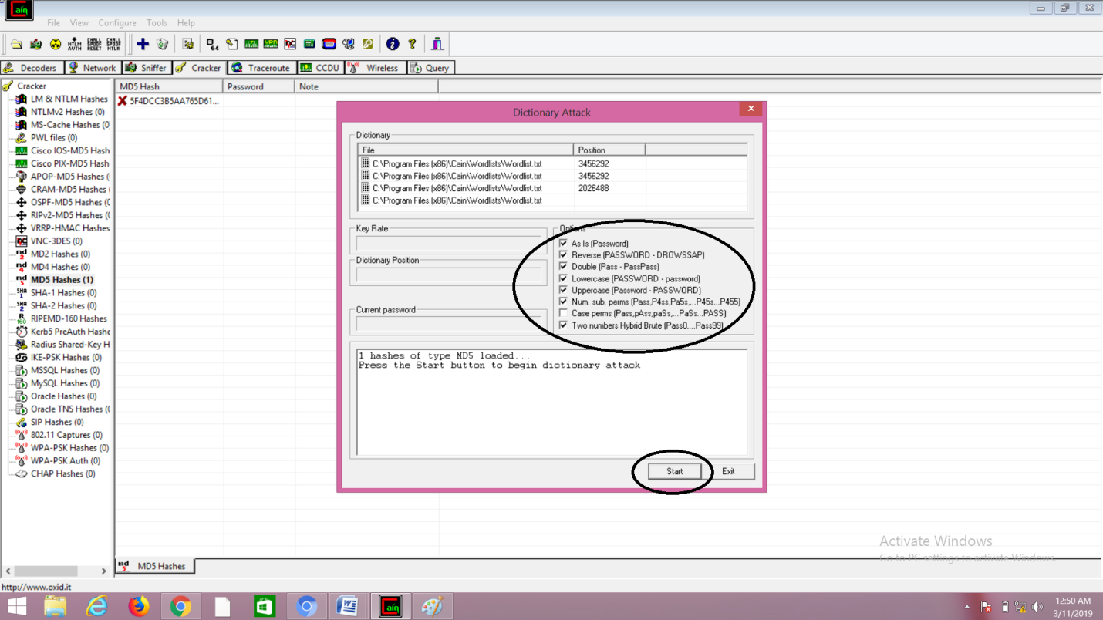

(8) Finally, you can see that your MD5 hash has been cracked.

